History Around us – An Activity Sheet for the OCR Unit
Below are 5 key turning points in the Roman Baths’ history. Features from each turning point will be flagged up to you as you explore the site.
43AD – the Romans invade Britain
- Baths and Temple completed by 75AD
- Baths at their greatest extent in 4th Century AD
5th Century AD – the Romans withdraw from Britain
The Baths fall into decline and are prone to flooding
18th Century –transformation of Bath
Rebuilding of the city leads to the discovery of Minerva’s head in 1727 and the discovery of the Gorgon’s head in 1790
Late 19th Century – discovery of the Great Bath
Workmen discover the Great Bath whilst attempting to repair a leak from the spring.
1960s – formation of the Bath Excavation Committee
Barry Cunliffe’s team unearth the curse tablets and the sacrificial altar in the 1960s, 1970s and 1980s

Late 19th Century
The Terrace
Look around you. What evidence is there that the Terrace is a later addition to the Roman Baths?
________________________________________________________________

Look behind you at the pictures on the screens of the Roman Baths in the late 19th Century. What describing words would you use for how they look?
________________________________________________________________

Walk outside and listen to audio guide 29? Why did the Victorians choose to erect these statues of Roman emperors?
________________________________________________________________

What can the Terrace teach us about the attitudes and values of the Victorians?
________________________________________________________________
43AD
Meet the Romans

Walk down into the museum. Listen to audio guide 16. Why did the Romans build the Baths here?
________________________________________________________________
Find the model of the Baths in the 4th Century. What does the model tell us about everyday life in Roman Britain?
________________________________________________________________

Take a seat in front of the Temple Pediment. Listen to audio guide 28. In what ways is the Gorgon’s head a ‘blend’ of Celtic and Roman?

18th Century
Life and Death in Aquae Sulis

Find the large stone head of a lady. This is from the 1st Century. It was discovered in 1714. The man who discovered it took it home and put it in his porch where it stayed for the next 150 years. Why do you think he did this?
________________________________________________________________
1960s

Worshipping the Gods and Temple Courtyard

Walk around the corner to find the lead curse tablets. These were discovered in the Sacred Spring in 1979. Listen to audio guide 36. Why are they regarded as one of the most important archaeological finds in Britain?
________________________________________________________________
What can we learn from the curse tablets about the attitudes and values of the Romans?
________________________________________________________________

Now walk into the Temple Courtyard which was excavated in 1981-83. You are standing 6 metres below a street. Why do you think that Roman floor level is so far below modern floor level?
________________________________________________________________

Find the sacrificial altar. Modern archaeologists discovered one of its corners built into the wall of a medieval church 13km away. What does this tell us about the attitude of people in the Middle Ages towards Roman remains?
________________________________________________________________

18th Century
Temple Courtyard and Sacred Spring

Find Minerva’s head and listen to audio guide 90. What was the statue likely to have looked like in Roman times?
________________________________________________________________

Minerva’s head was discovered by workmen digging a sewer. It was 12th July 1727. How do you think the fashionable people of Bath reacted to this discovery?
________________________________________________________________

Now walk until you can see the Sacred Spring. In the 18th Century, people called this the ‘King’s Bath’. Below is a picture of the King’s Bath in 1798. What similarities and differences can you spot between the Sacred Spring now and the King’s Bath then?

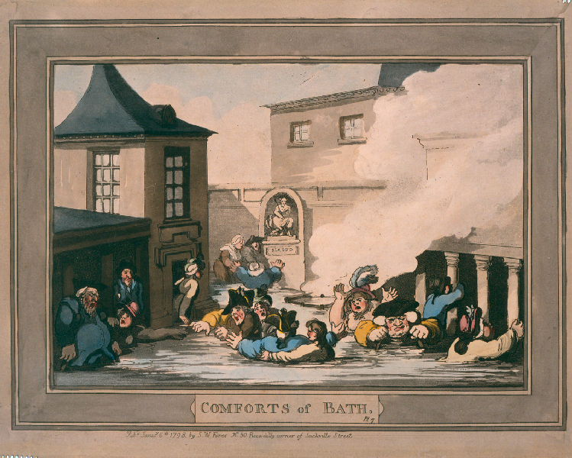

________________________________________________________________
________________________________________________________________

Coins and Roman Baths
5th Century

Find the coins that archaeologists have found in the Sacred Spring. They are helpful for dating when the Roman Baths were in use. What is the date of the last coin?
________________________________________________________________

Look at the pillars around the Great Bath. Find the point at which the Roman stonework ends and the Victorian stonework begins. Why are the pillars incomplete?
_______________________________________________________________
1960s
Late 19th Century
18th Century
5th Century
43AD

Which of the 5 ‘turning points’ do you think were most important? Say why.

